Advanced Chemistry

Weighing by Counting Name ________________________
Average Atomic Mass Date ___________ Block _______

- Look at the container of kernels at the front of the classroom. How would you determine the number of kernels in the container?
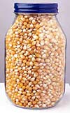
- See the diagram below and the percent compositions given to calculate the average atomic mass for carbon and hydrogen.
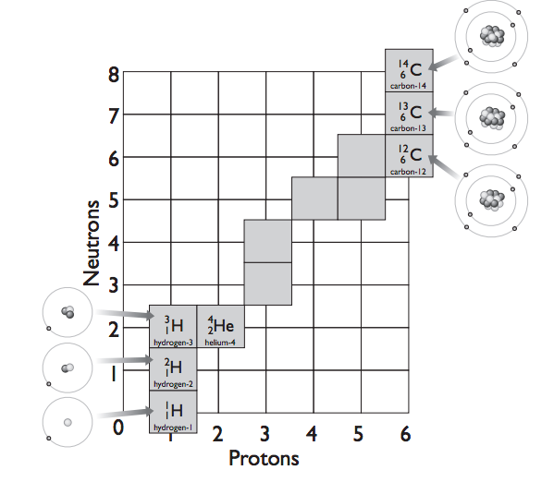
Hydrogen ¹H 99.9885%
Deuterium ²H 0.115%
Tritium ³H *

¹²C 98.93%
¹³C 1.07%
¹⁴C *

Explain why carbon has an average atomic mass of 12.01 and hydrogen has an average atomic mass of 1.008 even though they both have three isotopes.

* Negligible percent

3..Calcualte the average atomic mass for potassium given the information below.

³⁹K 93.2581%
⁴⁰K 0.0117%
⁴¹K 6.7302%
Average atomic mass = __________ Compare to the value on the periodic table.

