**Chapter 17: Equilibrium**

17.1 – Reaction rates and Equilibrium

Collision model of chemical reactions:



How can we affect the rate of a reaction?

Activiation energy (Ea):

How does a catalyst or an enzyme speed up a reaction?

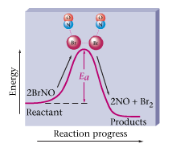 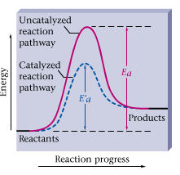

What does it mean if a reaction is at a state of equilibrium?

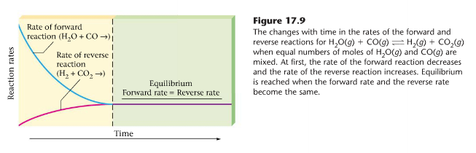

**Equilibrium is a dynamic process!!!**

17.2 – Characteristics of Equilibrium

Equilibrium constant for the given reaction:

 

*Note: pure liquids (ex. H2O) and solids are not included in the equilibrium expression.*

If K > 1 than the reaction favors the products

If K < 1 than the reaction favors the reactants

*Initial concentration of reactants or products doesn’t matter – K will always be the same for a given reaction *at the same temperature* (K depends on temp)

Example:

1) N2 (g) + 3H2 (g) ⇔ 2NH3 (g) K =

2) PCl5 (s) ⇔ PCl3 (l) + Cl2 (g) K =

17.3 - Le Chatlier’s Principle

Le Chatlier’s Principle: When you impose a change to a system at equilibrium it will shift in the direction to reduce the effects of the change.

Example:

N2 (g) + 3H2 (g) ⇔ 2NH3 (g) H = -92 KJ

Which way will the reaction shift if you:

1. Increase the amount of N2 gas?
2. Increase the amount of NH3 gas?
3. Increase the volume?
4. Decrease the volume?
5. Increase the temperature?
6. Decrease the temperature?

**Practice Problems**

1. Draw out an energy diagram for an exothermic reaction that includes the activation energy. How does the addition of a catalyst affect the activation energy? Describe the reaction in the reverse and show it’s activation energy.

2. Write an equilibrium expression for the following reactions:

a. P4 (g) + 6Br2 (g) ⇔ 4PBr3 (g) K =   
  
  
b. 4Al (s) + 3O2 (g) ⇔ 2Al2O3 (s) K=

3. Suppose the reaction system

CH4 (g) + 2O2 (g) ⇔ CO2 (g) + 2H2O (l)

has already reached equilibrium. Predict the effect of each of the following changes on the position of the equilibrium. Tell whether the equilibrium will shift to the right, will shift to the left, or will not be affected. Explain why.

1. Any liquid water present is removed

1. CO2 is added to the system by dropping a chunk of dry ice into the reaction vessel.

1. The reaction is performed in a metal cylinder fitted with a piston, and the piston is compressed to decrease the total volume of the system.
2. Additional O2 (g) is added to the system from a cylinder of pure O2.

**Answers**

1. See figure 17.2 The catalyst will decrease the activation energy. See figure 17.3 for a description of a catalyst. The reverse reaction will be the opposite as the forward reaction, it will be endothermic.

2a. 2b.

K = K =

3a. no effect 3b. shifts left 3c. shifts right 3d. shifts right