*Be sure you understand the concepts involved in each question. Do not simply memorize facts!*

Chapter 1: Chemistry
1. What is chemistry?

2. What is the difference between a physical and chemical change? Give an example of each.

3. What are 4 indications of a chemical change?

Chapter 2: Matter
4. What is matter?

5. What is the Law of Conservation of Matter?

6. Describe in words and make particle view drawings of the following.
Cation | Anion
Element | Compound
Mixture | Pure substance
Heterogeneous Mixture | Homogenous Mixture
Molecular Compound | Ionic Compound

7. Classify the following listed below.
paraffin, C₂₅H₅₂ table Salt, NaCl carbon dioxide, CO₂
oxygen, O₂ salt water air in the room
graphite, C water, H₂O homogenized milk
phosphorous, P₄ aluminum, Al sand and water
iced tea magnesium, Mg chicken noodle soup
Pure Substances |  |  |  | Mixtures
Element |  | Compound |  | Homogenous | Heterogeneous
Atomic | Molecular | Ionic | Molecular

Chapter 19.1: Nuclear Chemistry and Radioactivity
8. Define radioactivity.

9. Fill in the following table:
Particle Type | Description | Symbol | Example Decay Equation
Alpha

Beta

10. Write an equation for the beta decay of strontium-90

11. Write an equation for the alpha decay of uranium-238

12. Define half-life.

13. A given isotope has a half-life of 5.0 minutes. If the initial mass is 280 grams, how many
grams will be left after 15 minutes? How many half-lives is this?

Chapter 3: Elements, Atoms, and Ions; Atomic Theory
14. Compare the parts of an atom based on location, charge and mass:
 | location | charge | mass
proton
neutron
electron

15. Look at the two atoms listed: ¹²C and ¹³C
a. Why are these considered isotopes of carbon?
b. What is the atomic number? ____ Write it into the isotope notation above. How did
you find the atomic number? What does it represent? ___________________________

c. What are the mass numbers? _________ How did you find them? _________________
What do they represent? ___________________________________________________

d. What is an atomic mass unit? _______________________________________________

16. How many neutrons does U-238 have?

17. Write the isotope notation for the particle that contains 17 neutrons and 15 protons.
18. Fill in the following table:
Name | Symbol | Atomic # | Mass # | # protons | #neutrons | # electrons
sodium | Na | 11 |  |  | 11
silver | Ag |  | 108
copper(II) (cation) | Cu²⁺ |  |  | 29 | 34
chloride (anion) | Cl⁻ |  |  |  | 18
uranium | U |  | 238 |  |  | 92

19. The atomic mass of carbon as displayed on the periodic table is 12.011 amu. However, no
single carbon atom in nature has this mass. Explain.

20. If element Z (fictitious) has two isotopes: Z-20 (20.00 amu), and Z-21 (21.00 amu). If the
average atomic mass for element Z is 20.40 amu, which isotope has the greatest natural
abundance? Explain how you know this.

21. Show the location of each of the following on the periodic table:
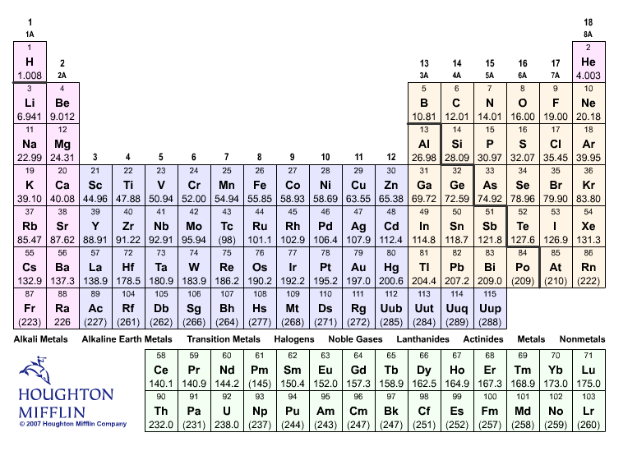
- periods
- groups or families
- main group elements
- metals
- non-metals
- metalloids
- alkali metals
- alkali earth metals
- transition metals
- halogens
- noble gases
- lanthanides
- actinides
- diatomic elements
- common ionic charges for groups 1, 2, 13, 14, 15, 16, 17

22. Describe 4 properties of metals, and 4 properties of non-metals:

23. What is a metalloid? What is another name for a metalloid?

24. Where are elements with similar properties found on the periodic table (in horizontal rows,
or in vertical columns?) Why?
Chapter 4: Chemical Formulas
25. Write the formula, give the matter classification and indicate the type of bonding found in the following:
Formula Classification Type of bonding
a. dinitrogen pentoxide ____________ ______________ _______________
b. lead ____________ ______________ _______________
c. diamond ____________ ______________ _______________
d. ammonium nitrate ____________ ______________ _______________
e. tin (II) chloride ____________ ______________ _______________
f. oxygen ____________ ______________ _______________

26. Write the name of the following, give the matter classification and indicate the type of bonding found in the following:
Name Classification Type of bonding
a. KMnO₄ ____________________ _______________ _______________
b. HNO₂ ____________________ _______________ _______________
c. PCl₃ ____________________ _______________ _______________
e. FeBr₃ ____________________ _______________ _______________
f. Na₂S ____________________ _______________ _______________
g. FeO ____________________ _______________ _______________

27. Hydrates can be described as ___________________________________________
Epsom salt is a common hydrate, it can be described chemically as magnesium sulfate
heptahydrate. What is the chemical formula for Epsom salt? _____________________
28. Describe how you can recognize, from the formulas or names, each of the following:
ionic compounds

molecular compounds

acids

hydrates

29. Complete the information below:
Reaction  Balance the Reaction | Chemical or Physical Change | Reactant(s)  Use the name | Product(s)  Use the name
___Fe (s) + ___O₂ (g) →___Fe₂O₃ (s)
Rust

Describe what is happening by:
a. Classify the reactant or product as an atomic element, molecular element, ionic compound
or a molecular compound.
______________ ________________ → ________________

b. Describe the state of each reactant and product.
______________ ________________ → ________________

c. Discuss the ratio between each of the reactants and product in the balanced equation.
______________ ________________ → ________________
Draw a particle view of what is happening in this reaction when 10 moles Fe₂O₃ are formed.

→
Chapter 5: Measurements and Calculations
Significant Figures/Measurements/Conversions
30. How many significant figures does each of the following measurements have?
a. 2300 m
b. 20040 m
c. 260.00 m
d. 0.00205 m
e. 4.65 x 10⁻⁴ m
31. Answer the following with the correct number of significant figures.
a. 4.535 m + 0.0251 m
b. 274 m - 254 m
c. 6.54 m / 3.4215 m
d. 30.67 m x 23 m

32. Convert -25°C to Kelvin _______ Convert 300. Kelvin to °Celsius ______

Chapter 6: Chemical Composition (Calculations Involving the Mole)
33. Distinguish between the following:
empirical formula

molecular formula

Questions 34-37 refer to the compound:
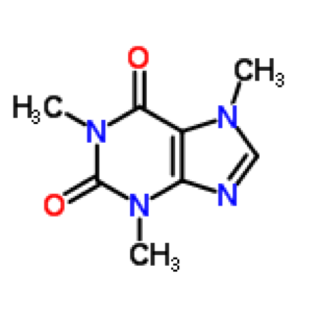Caffeine - Molecular Formula: C₈H₁₀N₄O₂

34. What is the empirical formula for caffeine? ___________
35. Calculate the molar mass for caffeine: __________ grams/mole

36. Calculate the percent composition of each element in the formula
% C = _______ % N = _______
% H = _______ % O = _______

37. Will Caffeine have the same percent composition if you calculated the percentage from the empirical formula or the molecular formula? Explain how you know, you may include a drawing or calculation.

____________________________________________________________________________
38. A compound is 35.0% nitrogen, 5.0% hydrogen, and 60.0% oxygen. What is the empirical formula of the compound?

39. What is a mole?

40. What is the mass of a mole of calcium atoms?

41. What is the mass of a mole of Mg(OH)₂?

42. What is the percentage of silver in silver sulfide, Ag₂S?

43. How many atoms are in 10.0 grams of aluminum?

44. How many grams is 3.4 x 10²⁴ carbon atoms?

45. How much copper can be purified from 750 grams of copper (I) sulfide?

Chapter 7: Types of Chemical Reactions
46. a. In a chemical equation, what are the:
- reactants?
- products?
- subscripts?
- coefficients?
b. What do the following symbols represent?
(s) (aq)
(l) → (yield sign)
(g) ∆ (delta sign)

47. When balancing equations, which can you change: the subscripts, or the coefficients?
Explain why.
Chapter 8: Reactions in Aqueous Solution
48. Describe each type of chemical reaction:
- synthesis:
- decomposition:
- single-replacement:
- precipitation (double-replacement):
- combustion:
- acid/base neutralization:
- oxidation/reduction reaction
49. What are the 4 driving forces for chemical reactions?

50. Use the solubility rules to label each of the following compounds as soluble or insoluble. (S) = Soluble or (I) = Insoluble in water
_____ a. magnesium hydroxide ______g. (NH₄)₃PO₄
_____ b. silver chloride ______h. Al₂S₃
_____ c. barium sulfate ______ i. HgSO₄
_____ d. potassium nitrate ______ j. Fe(OH)₃
_____ e. lead (II) nitrate ______ k. CaCO₃
_____ f. sodium carbonate ______ l. Co(NO₃)₃

51. Write the molecular, ionic, and net ionic equations for the reaction between:
barium chloride and sodium sulfate
a. molecular equation _______________________________________________

b. ionic equation _______________________________________________

c. net ionic equation _______________________________________________

52. Balance, then identify the type of reaction:
A = acid/base reaction
B = precipitation reaction
C = oxidation/reduction reaction
C₁ = synthesis, C₂ = decomposition, C₃ = single replacement, C₄ = combustion

____ 1. __CdCO_{3(s)} ------------> __CdO_{(s)} + __CO_{2(g)}
____ 2. __Mg_{(s)} + __HCl_{(aq)} --------> __H_{2(g)} + __MgCl_{2(aq)}
____ 3. __CaBr_{2(aq)} + __AgNO_{3(aq)} -----> __Ca(NO₃)_{2(aq)} + __AgBr_{(s)}
____ 4. __HCl_{(aq)} + ___NaOH_{(aq)} ----------> ___H₂O_{(l)} + ___NaCl_{(aq)}
____ 5. __PbCl_{2(aq)} + __Li₂SO_{4(aq)} --------> __LiCl_{(aq)} + __PbSO_{4(s)}
____ 6. __As_{(s)} + __O_{2(g)} --------> __As₂O_{5(s)}
____ 7. __CH_{4(g)} + __O_{2(g)} ---------> __CO_{2(g)} + __H₂O_{(g)}

