1. These two radioactive elements that are alpha particle (*α*) emitters. Write the nuclear reactions for each decay including the formation of the daughter products:
   1. ${}_{84}^{213}{Po}$ →
   2. ${}_{93}^{241}{Np}$ →
2. These two radioactive elements that are beta particle (*β*–) emitters. Write the nuclear reactions for each decay including the formation of the daughter products:
   1. ${}_{7}^{ 15}N$ →
   2. ${}_{19}^{41}K$ →
3. These two radioactive elements that are positron (*β*+) emitters. Write the nuclear reactions for each decay including the formation of the daughter products:
   1. ${}_{27}^{56}{Co}$ →
   2. ${}_{33}^{80}{As}$ →
4. These two radioactive elements decay by electron capture (*EC*). Write the nuclear reactions for each decay including the formation of the daughter products:
   1. ${}_{16}^{35}S$ + ${}_{-1}^{0}e$ →
   2. ${}_{35}^{69}{Sr}$ + ${}_{-1}^{0}e$ →
5. Balance each nuclear decay equation by filling in the blanks. Classify each nuclear decay as alpha (α), beta (β−), positron (β+), or electron capture (EC):
   1. →  +  Type of decay:
   2.  +  → _______ Type of decay:
   3. ${}_{15}^{34}P$ →  _______ Type of decay:
   4. ${}_{11}^{22}{Na}$ →  + ${}_{10}^{22}{Ne}$ Type of decay:
   5. +  →  Type of decay:
   6.  →  + _______ Type of decay:
   7.  → _______ +  Type of decay:
   8. ${}_{21}^{48}{Sc}$ → ${}_{22}^{48}{Ti}$ + _______ Type of decay:

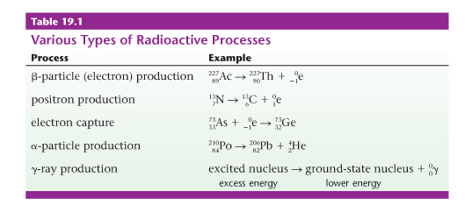

Show all work; observe all significant figures, and record units with all answers.

1. Americium-247 undergoes beta decay to curium-247 with a half-life of 23 minutes.
   1. Write the complete nuclear decay reaction for this process, using full symbols for all isotopes and particles.
   2. How many half-lives will it take for 75% of a 350 gram sample of americium-247 to decay to curium-247?
   3. If one starts with a 1000 g sample of americium-247, what mass of americium-247 will remain after 92 minutes?
2. The half life of cobalt-60 is 5.3 years. How much of a 1.000 mg sample of cobalt-60 is left after a 2.15 year period?
3. The half-life of tritium (hydrogen-3) is 12.3 years. If 48.0 mg of tritium is released from a nuclear power plant during the course of an accident, what mass of this nuclide will remain after 12.3 years? After 74.2 years?
4. The half life of Plutonium- 239 is 24,000 years. What fraction of the Plutonium-239 present in nuclear wastes generated today will be present in the year 3000?