Types of IMF
Types of Solids
Crystalline Solids
As solid whose atoms, ions, or molecules are arranged in an orderly geometric structure. They are represented on a framework called a crystal lattice. See the picture below for various cell types and shapes.
Molecular Solids/ Atomic Solids
Solid crystal structures held together by intermolecular forces.
Examples:

Covalent network solids
A solid that forms multiple covalent bonds.
Examples:

Ionic Solids
Ions of opposite charge held together by ionic bonds.
Examples:

Metallic Solids
Positive metal ions surrounded by a sea of mobile electrons. There are pure metals and mixtures of metals called alloys.
Examples:

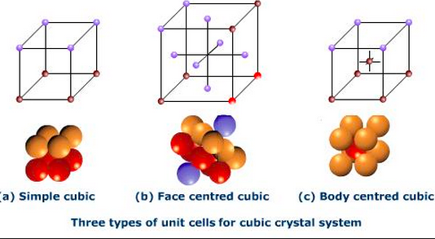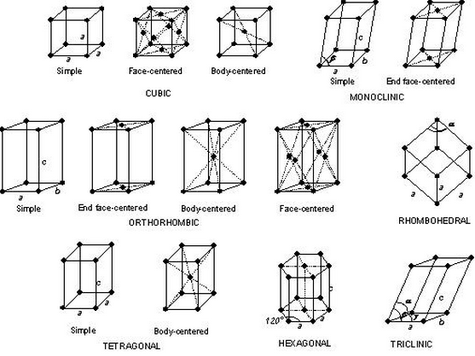
Amorphous Solids
Solid where the particles are not arranged in a regular, repeating pattern.
Examples:
Questions
1. Describe the difference between a molecular solid and a covalent network solid.

2. Predict which solid will be amorphous – one formed by allowing molten material to cool slowy to room temoerature or one formed by quickly cooling the same material to room temperature. Why?

3. Ionic solids typically have melting points hundreds of degrees higher than the melting points of molecular solids. Explain why.

4. Match the following terms to the definition or description:
a. alloy b. specific heat c. crystalline solids d. dipole-dipole interactions
e. equilibrium vapor pressure f. intermolecular g. intramolecular h. ionic solids
i. London dispersion forces j. molar heat of fusion k. molar heat of vaportization
l. Molecular solids m. normal boiling point n. semiconductor
_____ boiling point at a pressure of 1 atm
_____ energy required to melt 1 mole of a substance
_____ forces between atoms in a molecule
_____ forces between atoms in a solid
_____ instantaneous dipole forces for nonpolar molecules
_____ lining up of opposite charges on adjacent polar molecules
_____ maximum pressure of vapor that builds up in a closed container

