Smells Lab Name:
Honors Chemistry Date: _____ Period:

Record the smell of each of the following samples.

Compound | Name | Structural Formula | Molecular formula | Smell
A | l-carvone | 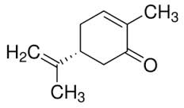 | C₁₀H₁₄O₁
B | phenylethylamine | 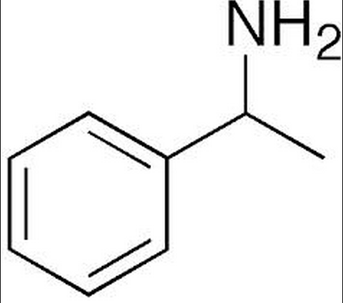 | C₈H₁₁N
C | pentyl propionate | 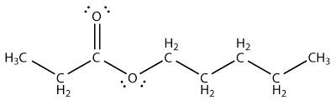 | C₈H₁₆O₂
D | isopentyl acetate | 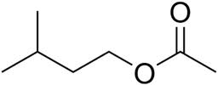 | C₇H₁₄O₂
E | menthone | 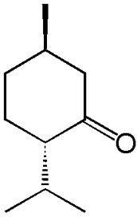 | C₁₀H₁₈O₂
F | ethyl acetate | 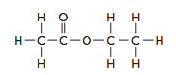 | C₄H₈O₂
G | 2-quinolinemethanethiol | 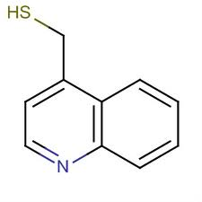 | C₁₀H₉NS
H | cadaverine | 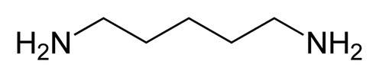 | C₅H₁₄N₂
I | putrescine | 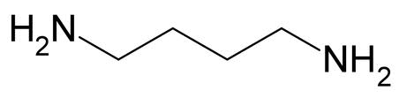 | C₄H₁₂N₂
J | hexanoic acid | 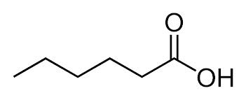 | C₆H₁₂O₂
K | butyric acid | 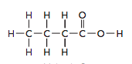 | C₄H₈O₂

Post-Lab Questions

- Molecules can be grouped into one of the four main categories of smell: sweet, minty, putrid or fishy. Group the molecules in your lab by smell below, then go to your teacher to find out what they really are!

Sweet
Name | Molecular Formula | What is it really?

What common properties do you notice between the molecules that smell sweet?

Putrid
Name | Molecular Formula | What is it really?

What common properties do you notice between the molecules that smell putrid?

Minty
Name | Molecular Formula | What is it really?

What common properties do you notice between the molecules that smell minty?

Fishy
Name | Molecular Formula | What is it really?

What common properties do you notice between the molecules that smell fishy?

- Build the molecule assigned to your lab group from your teacher. Sketch its structural formula. Draw in dipoles along each polar bond and indicate whether you expect the molecule overall to be polar or non-polar.

- Would you expect the molecule discussed in #2 to dissolve in water? Why or why not?

- Observe all of the models for the compounds in the lab. Sort the compounds into 2 groups – polar molecules and non-polar molecules.

