Study Guide for Unit 3 Part II Test
Daigneault Chemistry
- Organize your materials
  - Your reading journal notes:
    - Ch 15 section 2 part B, questions 28-30 pg 556
    - Ch 16 section 2 and section 3 part A
    - Ch 18.3 A and B
  - Class notes:
    - Molarity and Dilutions
    - Acids/ Bases and pH
    - Titrations
    - RedOx and Electrochemistry
  - pH scale worksheet
  - Assay for Acetic Acid in Vinegar
  - Lemon Battery Lab
  - U3 – Part 2 - Review Worksheet
- Read over all materials listed above, be sure they are complete and you understand each of them.
- Reread the assigned sections from the book – Make your own Study Guide in your reading journal.
  - If you did not earn a 85% or better on the last test you must hand write your study guide with the following 3 sections:
    - Vocabulary section (optional)
Include all bold vocabulary from each section as well as any words you do not understand and know. See attached chapter review for a list of bold words.
    - Outline notes section
From each section we covered write bulleted notes. Use the chapter review at the end of the chapter on pg. 270 for guidelines and ideas of what to include.
Include at least one example with the answer from the examples boxes in the section as you take notes.
    - Example section
- Redo at least 2 examples from each of the in class and homework problems assigned from the list above. You may reprint the worksheets and attach them to your study guide.
- Complete 1-3 of the section review questions at the end of each section.
- Mark areas that you need to review and then GO BACK in the textbook and study each of these sections.

- On the test you will be allowed:
  - Your periodic table with appropriate marks
- Review your study guide and reading journal, get some sleep and a good breakfast!

Station 1 Solutions
1. Describe how you would prepare 100 mL of a 1.5M KOH solution.
You have the following materials and equipment available.
KOH (s), distilled water, balance, 100 mL volumetric flask, beaker, 10 mL graduated cylinder

How many moles of each ion are in the solution?

2. Describe how you would prepare 100 mL of a 0.5 M KOH solution from the solution above.
1.5M KOH solution, distilled water, 100 mL volumetric flask, beaker, 10 mL graduated cylinder

3. If 0.50 moles of KBr is present in 250 milliliters of solution, calculate the molarity of the solution.

4. If 45.3 grams of NaNO₃ is dissolved in enough water to make 225 mL of solution, what is the molarity of the solution?

Station 2 - Acids and Bases
Properties
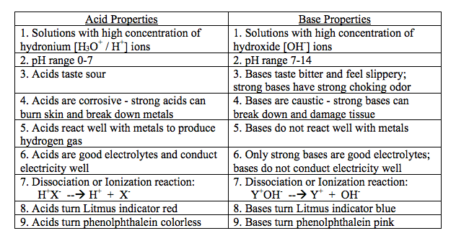

Acid and Base strength
Strong vs. weak
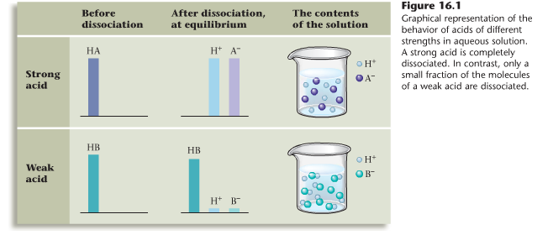
Water
Water undergoes auto-ionization to dissociate and produce acidic or basic ions freely dissolved in solution.

Amphoteric: Water has both acid and base properties

H₂O (l) + H₂O (l) ⇔ H₃O⁺ (aq) + OH⁻
Equilibrium Constant: Kw = [H₃O⁺] [OH⁻] = 1.0 x 10⁻¹⁴ at 25°C

No matter what water contains the K_{w} of any aqueous solution must have a product equal to 1.0 x 10⁻¹⁴ at 25°C.
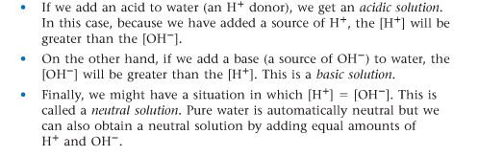
pH scale
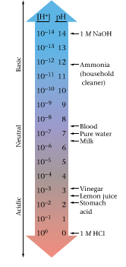

For each of the following solutions, tell the pH value, the [H⁺], and the [OH⁻] .
pH range [H⁺] (high/low) [OH⁻] (high/low)
Acid solution _______ _______ _______
Base solution _______ _______ _______
Neutral solution _______ _______ _______
Example
Find the pH or the concentration of ion of these "decimal" acids and bases!
Concentration of ion pH Acid or base
[H⁺] = 1 x 10⁻⁶ ______ __________
[H⁺] = 1 x 10⁻⁹ ______ __________
[H⁺] = ____________ 13 __________

Titrations and Neutralization Reaction
Fill in the titration diagram below and describe how you could use a titration experiment to determine the concentration of a basic solution using an acid with a know concentration. Be sure to include what measurements and observations you would make. Use the following words in your answer: buret, indicator, flask, base, acid, color change
and describe what is happening while indicating the color of the solution in the flask at the start, throughout and end of the reaction.

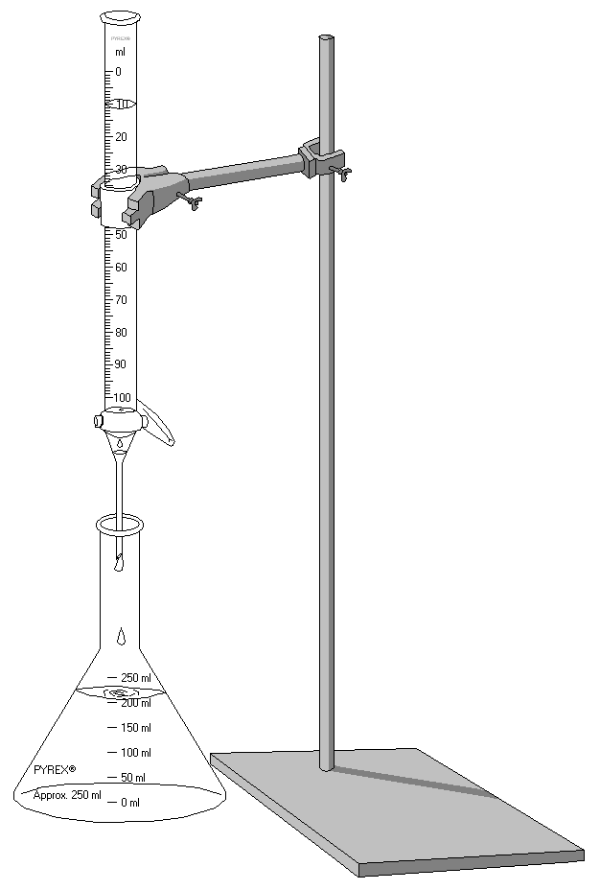

Write a balanced equation for the neutralization reaction between HCl and Ca(OH)₂.

Draw out the Acid/ Base reaction below:

+  

What volume of 1.0 M HCl would you need to titrate in order to neutralize 10 mL 2.0 M Ca(OH)₂?

Electrochemistry
Balance the reaction below.

____ Zn _{(s)} + ____ AgCl _{(aq)} ____ ZnCl₂ _{(aq)} + ____ Ag _{(s)}
Draw out the RedOx reaction below:

+  

Identify the element that is reduced, the element that is oxidized, the reducing agent, the oxidizing agent, the reduction half-reaction, the oxidation-half reaction and the total number of electrons transferred.
WHO
Element reduced: __________ Element oxidized: ____________
Reducing agent: ___________ Oxidizing agent: _____________
HOW
Reduction half-reaction: ___________________________________________________

Oxidation half-reaction: ____________________________________________________
WHAT
Total number of electrons transferred ____________________
Draw a standard voltaic cell for the reaction
Zn| Zn²⁺ || Ag⁺ |Ag
half reaction:

label

half reaction

Label the anode, cathode, and salt bridge. An Ox – Red Cat

Draw in an arrow to indicate the direction of electron flow along the wire

Give 2 examples of practical applications of electrochemical cells

