VESPR Rules for Molecular Geometry and Polarity Advanced Chemistry

Name ________________________
Block ____________

VESPR
Molecules will orientate themselves in space such that their atoms and unshared electron pairs have as much space as possible. This is what we call the Valence Electron Shell Repulsion theory or VESPR.

In order to predict the geometry of a molecule you must first have an accurate Lewis structure drawing. Then you will look to the central atom to count the number of electron pairs off the center and bonds formed from the electron pairs. This information will help you to determine what the 3 dimensional geometry of the molecule will be. Use the table below to help you to classify and remember the geometries we study and go over in class. This table is from your textbook pg 431.
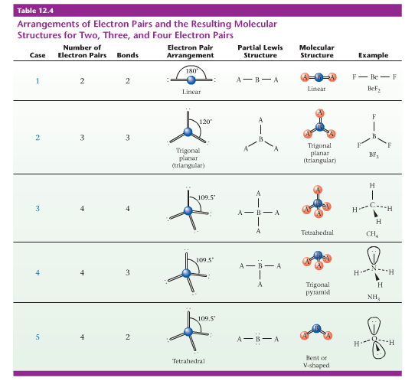
Polarity
When we discuss polarity please remember there are two types of polarity to consider.
- Bond polarity – this type of polarity results from the two bonded atoms having a EN between 0.5 and 2.0.
- Molecular polarity – this type of polarity results from the overall shape of the molecule being unsymmetrical. In order to determine molecular polarity an accurate Lewis structure must be drawn and the geometry must be examined.

